Branching and Merging

Branching:
- Set P4Merge as your diff and merge tool


- Create a new branch
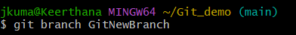

- List all branches
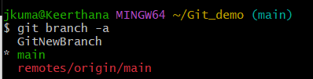

- Switch to the new branch
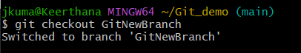

- Add new files with content
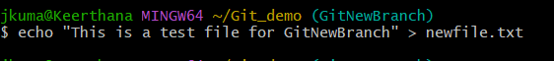

- Stage & commit
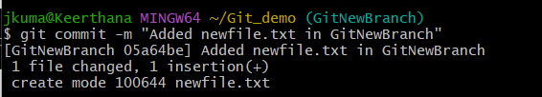

- Check status


Merging:
- Switch back to main


- List differences between main and GitNewBranch (CLI view)
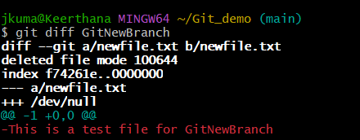

- View visual differences using P4Merge

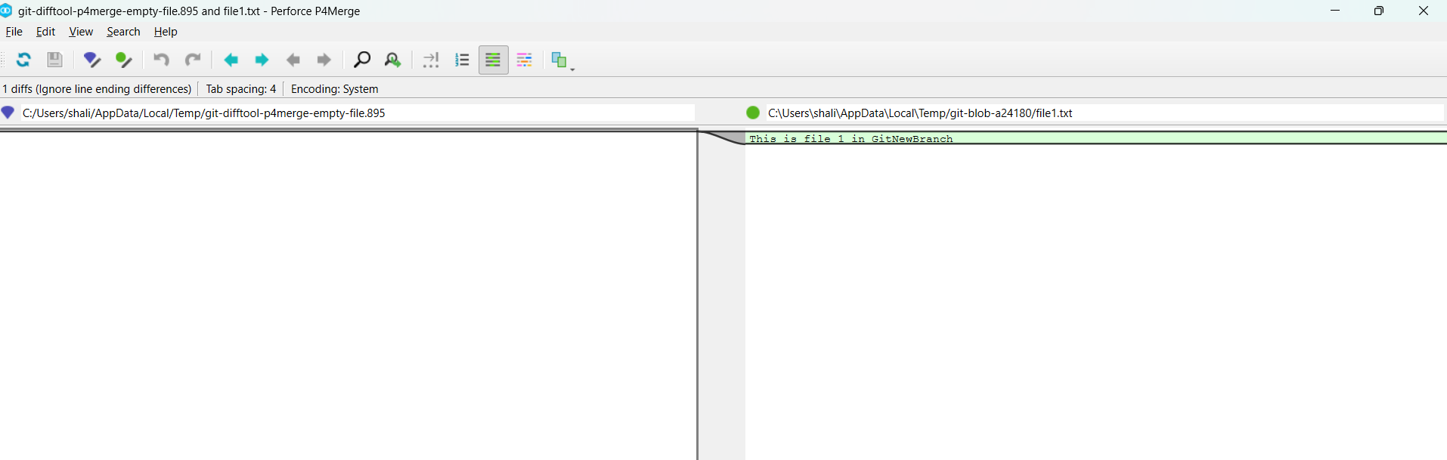

- Merge the branch into main
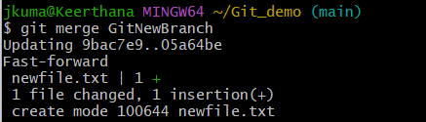

- If there are conflicts, git will open P4Merge
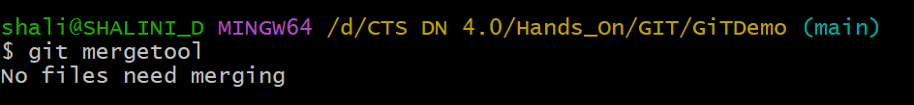

- View merge history
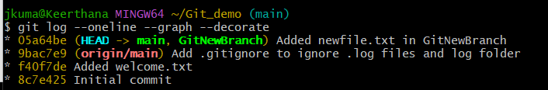

- Delete the merged branch

- Check the status
